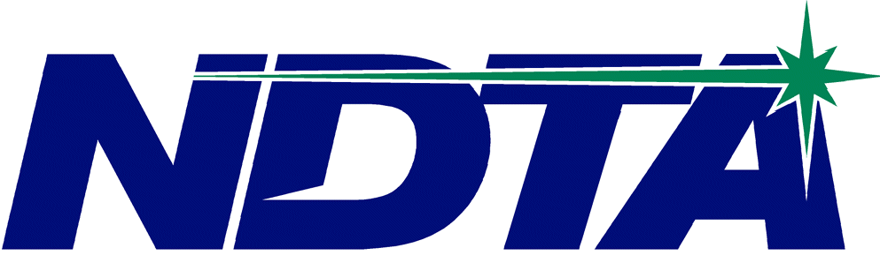
North Dakota Telephone Association

3615 North Broadway

PO Box 2027

Minot, ND 58702-2027
Tel: 701-858-5313
Fax: 701-858-1414
Email: admin@ndta.net
Website: www.ndta.net
NDTA/TOC Coordinator: Brittany Armstrong

APPLICATION FOR ASSOCIATE MEMBERSHIP

Our company hereby makes formal application for Associate Membership in North Dakota Telephone Association for the year 2023. It is understood that an Associate Membership does not entitle us to a voting right in the association business. The information submitted will be listed in the digital 2023-2024 NDTA Membership Directory available on ndta.net.

COMPANY:
ADDRESS:
CITY, STATE, ZIP:
PHONE:
FAX:
Web Site:

Company Representative:
Title:
E-Mail:
Phone, if different from headquarters:
Fax, if different from headquarters:
Cell (optional):

ANNUAL MEMBERSHIP DUES: $100 (Check one)
________ Check to be mailed
________ Email invoice
________ Contact NDTA to pay with credit card

Please Describe Your Product or Service:

